**Supplementary material**

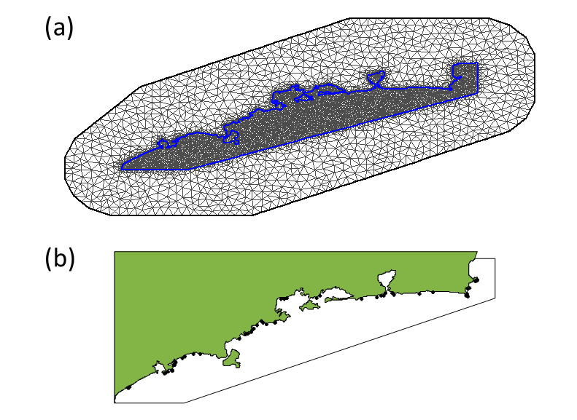

**Figure S1**. Mesh used in spatial models predicting average barnacle density per location. The mesh (*a*) is made out of triangles of varying side length, with the maximum length set to 5 km and 25 km for the inner and outer region. The sampling locations (*b*: black dots) are in the inner region; the outer region is created in order to facilitate computations at the border of the mesh. The mesh is made out of 8131 nodes, providing a matrix for the calculation of the spatially correlated random effects. For the barrier model, the same mesh is used but with constraints imposed at the limits of the inner mesh (demarcated by a blue line).

*Environmental drivers*

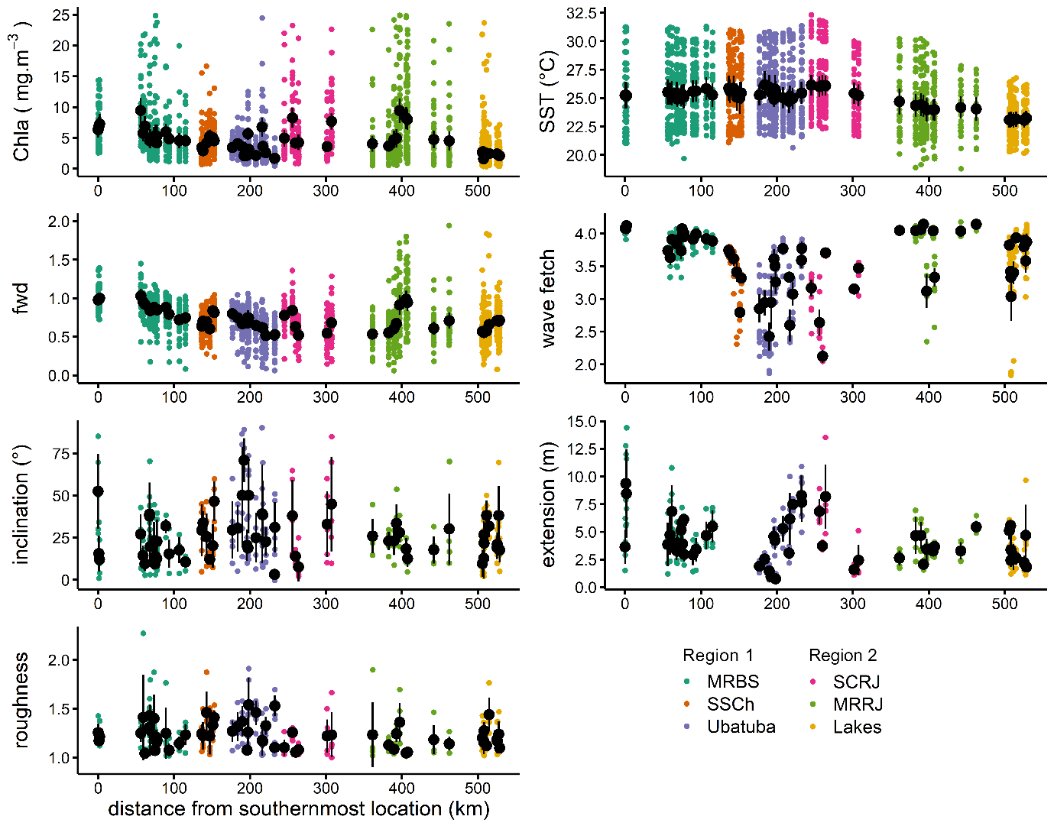

**Figure S2.** Environmental variables measured for studied locations along southeast coast of Brazil. Coloured circles are raw data while black circle and error bars represent mean ± 2*SE. Distance from southernmost location was used as *x*-axis since SE coast of Brazil is very intricate and locations tens of kilometres apart may have same or close latitudes. Wave fetch is shown in log10 number of cells. *Abbreviations*: fwd = freshwater discharge index; MRBS = Metropolitan Region of Baixada Santista; SSCh = São Sebastião Channel; SCRJ = south coast of Rio de Janeiro; MRRJ = Metropolitan Region of Rio de Janeiro. (Source: Pardal *et al.* 2021)

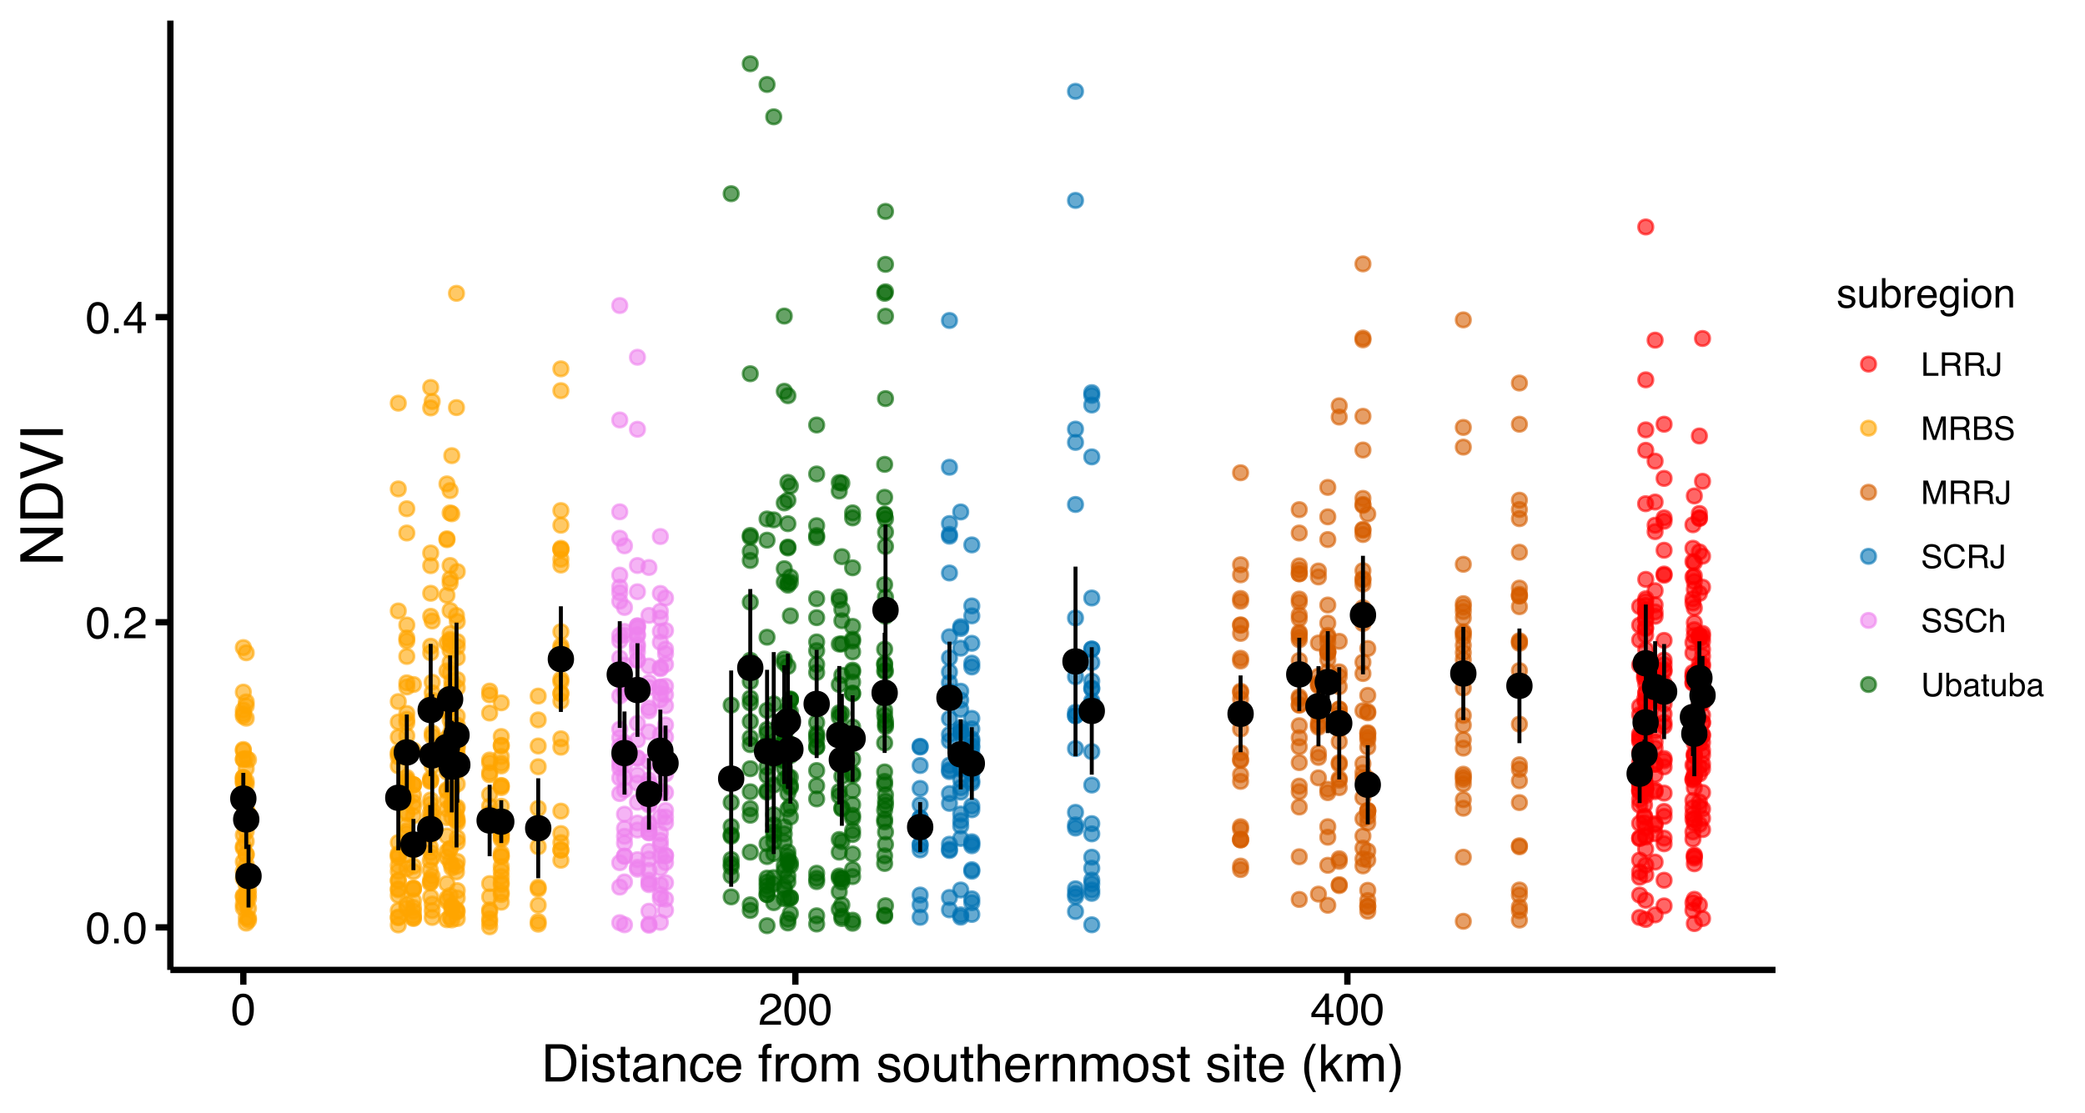

**Figure S3**. Normalized Difference Vegetation Index (NDVI) measured for studied locations along southeast coast of Brazil. Coloured circles are raw data, while black circle and error bars represent mean ± 2*SE. MRBS = Metropolitan Region of Baixada Santista; SSCh = São Sebastião Channel; SCRJ = south coast of Rio de Janeiro; MRRJ = Metropolitan Region of Rio de Janeiro.

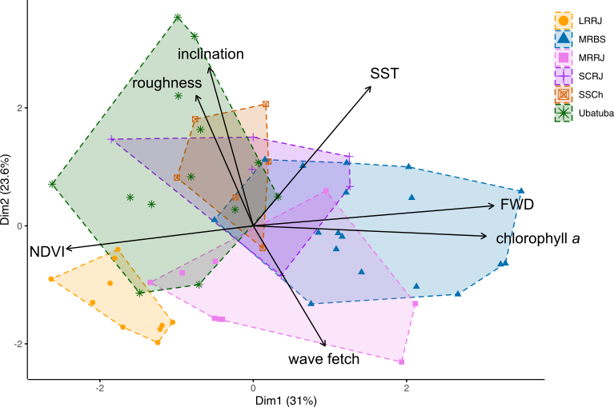

**Figure S4.** Principal components analysis of environmental drivers of 62 rocky shores along southeast coast of Brazil. FWD = freshwater discharge index; NDVI = normalized difference vegetation index; SST = sea surface temperature; MRBS = Metropolitan Region of Baixada Santista; SSCh = São Sebastião Channel; SCRJ = south coast of Rio de Janeiro; MRRJ = Metropolitan Region of Rio de Janeiro.

|  |
| --- |
| (a) |
| (b) |

**Figure S4***.* Plots of residuals versus geographical coordinates (a) and fitted values (b) of models for *Lottia subrugosa* density: (a) non-spatial, (b) range == 500 and Gamma distribution of residuals.

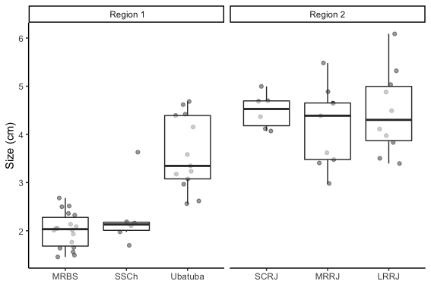

**Figure S5**. Size variation of *Echinolittorina lineolata* along 62 rocky shores on southwestern Atlantic coast (Brazil) according to region and subregion. ANOVA: *F-value* 5, 56 = 35.33, p < 0.001; Tukey test, Region 1: MRBS = SSCh ≠ Ubatuba; Region 2: SCRJ = MRRJ = LRRJ. MRBS = Baixada Santista; SSCh = São Sebastião Channel; SCRJ = Costa Verde; MRRJ = Rio de Janeiro; LRRJ = Lagos.

|  |
| --- |
| (a) |
| (b) |
| (c) |

**Figure S6***.* Plots of residuals versus fitted values and geographical coordinates of *Tetraclita stalactifera* density models: (a) non-spatial, (b) range = 500 and Gaussian distribution of residual, (c) range = 500 and Gamma distribution of residuals. A smooth spline is shown for scatterplots graphs.

**Table S1**. Correlation between the environmental variables with the first two axes of RDA analysis of the final reduced model (p<0.05).

|  |  |  |
| --- | --- | --- |
| **Predictors** | **RDA1** | **RDA2** |
| Wave fetch | 0.851 | -0.093 |
| SST | -0.036 | -1.025 |
| Freshwater index | 0.376 | 0.062 |

**Table S2**. Summary statistics for models to the location averaged *Lottia* *subrugosa* densities fitted through INLA with chlorophyll and wave fetch as predictor. Spatial models differed in the prior for the range of the Matern spatial correlation function (*i.e*. the distance at which spatial autocorrelation becomes minimal, either 500 or 1000 km). The parameter estimates comprise the posteriors the range, σu, and the effect of chlorophyll and wave fetch (parameter estimate = β, credible interval 95% = CI).

|  |  |  |  |  |  |  |  |  |
| --- | --- | --- | --- | --- | --- | --- | --- | --- |
|  |  |  | **Intercept** | | **Chl-a** | | **Wave fetch** | |
| **Model** | **σu** | **Range** | **β** | **CI 95%** | **β** | **CI 95%** | **β** | **CI 95%** |
| Spatial 1000 | 0.58 | 108.8 | 2.44 | -0.86, 5.79 | -0.55 | -0.86, -0.25 | 5.68 | 0.16, 11.20 |
| Spatial 500 | 0.58 | 55.2 | 2.40 | -0.83, 5.67 | -0.55 | -0.82, -0.55 | 5.73 | 0.28, 11.19 |

**Table S3**. Model selection for *Tetraclita stalactifera* density.

|  |  |  |  |
| --- | --- | --- | --- |
| **Residuals** | **Predictors** | **Spatial 500** | **Spatial 1000** |
| Gaussian | SST+WF | 450 | 450 |
| Gaussian | WF | 454 | 455 |
| Gaussian | SST | 452 | 452 |
| Gamma | SST+WF | 424 | 423 |
| Gamma | WF | 437 | 437 |
| Gamma | SST | 423 | 423 |

**Table S4**. Summary statistics for models to the location averaged *Tetraclita* *stalactifera* densities fitted through INLA with SST as predictor and gamma residuals and logarithmic link function. Spatial models differed in the prior for the range of the Matérn spatial correlation function (*i.e*., the distance at which spatial autocorrelation becomes minimal, either 500 or 1000 km). The parameter estimates comprise the posteriors the range, σu, and the effect of chlorophyll-a and wave fetch (parameter estimate= β, credible interval 95% = CI).

|  |  |  |  |  |  |  |
| --- | --- | --- | --- | --- | --- | --- |
|  |  |  | **Intercept** | | **SST** | |
| **Model** | **σu** | **Range** | **β** | **CI 95%** | **β** | **CI 95%** |
| Spatial 500 | 0.15 | 73 | 13.33 | 8.24, 18.62 | -0.41 | -0.62, -0.20 |
| Spatial 1000 | 0.15 | 314 | 13.53 | 8.38, 18.95 | -0.42 | -0.63, -0.21 |

**Appendix A: Model selection and validation**

Before starting the analysis, all variables were explored for descriptive statistics (distribution type, central tendency, value range), simple correlations, collinearity and spatial dependency which are not shown here. Below are described the indicated statistics from model selection and validation.

*Stramonita brasiliensis*

**Table A1.** Fully nested random models fitted (residual maximum likelihood method) for size and density of whelk *Stramonita brasiliensis* in rocky shores along southeast coast of Brazil. Selection of the best model was based on lowest AICc value, next model higher complexity or ΔAIC > 3. Abbreviations: ~ 1 = no random factor, R = region, S = subregion and L = location. Size was log-transformed. Models for density including ‘location’ could not be tested because of lack of replication at this level.

|  |  |  |  |  |  |  |  |  |
| --- | --- | --- | --- | --- | --- | --- | --- | --- |
| **Size (Gaussian distribution, identity link)** | | | |  | **Density (Negative binomial, log link)** | | | |
| **model** | **logLik** | **AICc** | **dAICc** |  | **model** | **logLik** | **AICc** | **dAICc** |
| ~ L* | -5008.1 | 10044.8 | 0.0 |  | ~ 1* | -232.0 | 498.7 | 0.0 |
| ~ L + S | -5008.3 | 10046.6 | 1.8 |  | ~ R | -232.0 | 502.2 | 3.6 |
| ~ R + L | -5008.1 | 10046.9 | 2.0 |  | ~ S | -232.0 | 502.2 | 3.6 |
| ~ R + S + L | -5008.3 | 10048.6 | 3.8 |  | ~ R + S | -232.0 | 506.0 | 7.3 |
| ~ R | -5276.2 | 10580.6 | 535.7 |  |  |  |  |  |
| ~ R + S | -5276.1 | 10582.4 | 537.6 |  |  |  |  |  |
| ~ R | -5308.1 | 10644.4 | 599.5 |  |  |  |  |  |

* best random structure. Fixed structure of models: size or density ~ shore extension + shore inclination + wave fetch + SST + roughness + [Chl-a] + NDVI + *Tetraclita stalactifera* density + *T. stalactifera* cover + *Mytilaster* *solisianus* cover + *M. solisianus* size.

|  |  |
| --- | --- |
| (a) | (b) |
|  | |

**Figure A1***.* Plots of residuals versus fitted values, mean wave fetch (km log) and histogram of residuals of best model for *Stramonita brasiliensis* density (a) and size (b). A smooth spline is shown for scatterplots graphs.

**Table A2.** Fully nested random models fitted (residual maximum likelihood method) for the size of barnacle *Tetraclita stalactifera* in rocky shores along southeast coast of Brazil. Selection of the best model was based on lowest AICc value, next model higher complexity or ΔAIC > 3. Abbreviations: R = region, S = subregion and L = location. Size was log-transformed.

|  |  |  |  |  |
| --- | --- | --- | --- | --- |
| **Size (Gaussian distribution, identity link)** | | | |  |
|  | **logLik** | **AICc** | **dAICc** |  |
| ~ L* | 243.9 | -467.3 | 0.0 |  |
| ~ R + L | 244.5 | -466.4 | 0.9 |  |
| ~ S + L | 243.9 | -465.3 | 2.0 |  |
| ~ R + S + L | 244.5 | -464.3 | 3.0 |  |
| ~ S | 233.6 | -445.8 | 20.4 |  |
| ~ R + S | 234.0 | -445.6 | 21.7 |  |
| ~ R | 232.9 | -445.4 | 21.9 |  |

* best random structure. Fixed structure of models: size or density ~ shore extension + shore inclination + wave fetch + SST + roughness + [Chl-a] + NDVI + *Stramonita brasiliensis* size + *S. brasiliensis* abundance



**Figure A2***.* Plots of residuals versus fitted values, freshwater influence index and histogram of residuals of best model for *Tetraclita stalactifera* size. A smooth spline is shown for scatterplots graphs.

*Mytillaster solisianus*

|  |  |
| --- | --- |
|  |  |
|  |  |

**Figure A5***.* Plots of residuals versus fitted values, histogram of residuals, wave fetch (km log), and freshwater index of best model for *Mytillaster solisianus* cover.

|  |  |
| --- | --- |
|  |  |
|  |  |

**Figure A6***.* Plots of residuals versus fitted values, histogram of residuals, and sea surface temperature of best model for *Mytillaster solisianus* size.

*Lottia subrugosa*

**Table A3.** Fully nested random models fitted (residual maximum likelihood method) for size of limpet *Lottia subrugosa* in rocky shores along southeast coast of Brazil. Selection of the best model was based on lowest AICc value, next model higher complexity or ΔAIC > 3. Abbreviations: R = region, S = subregion and L = location. Size was log-transformed.

|  |  |  |  |
| --- | --- | --- | --- |
| **Size (Gaussian distribution, identity link)** | | | |
|  | **logLik** | **AICc** | **dAICc** | |
| ~ S + L* | -185.5 | 393.4 | 0.0 | |
| ~ R + S + L | -185.4 | 395.3 | 1.9 | |
| ~ L | -190.5 | 401.3 | 7.9 | |
| ~ R + L | -189.7 | 401.9 | 8.5 | |
| ~ S | -222.0 | 464.3 | 71.0 | |
| ~ R + S | -222.0 | 466.3 | 73.0 | |
| ~ R | -250.9 | 522.2 | 128.8 | |

* best random structure. Fixed structure of models: size or density ~ shore extension + shore inclination + wave fetch + SST + roughness + [Chl-a] + NDVI

|  |  |
| --- | --- |
|  |  |
|  |  |

**Figure A7***.* Plots of residuals versus fitted values, sea surface temperature (SST), roughness and histogram of residuals of best model for *Lottia subrugosa* size.

*Echinolittorina lineolata*

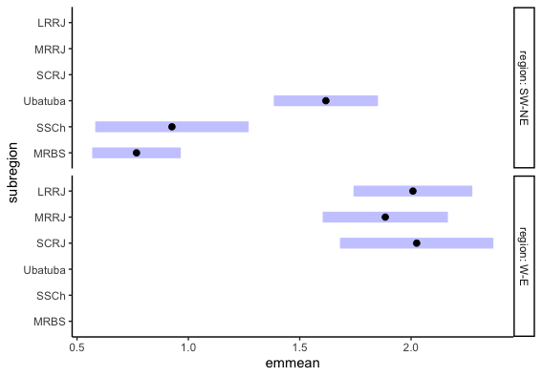

**Figure A8***.* Plots of random effects for the null model for *Echinolittorina lineolata* size and subregion (a), and for density and region (b).

|  |  |  |  |  |  |  |  |  |  |  |  |  |  |  |  |  |
| --- | --- | --- | --- | --- | --- | --- | --- | --- | --- | --- | --- | --- | --- | --- | --- | --- |
| **Type** | **Drivers** | ***Stramonita*** | | | ***Lottia*** | | | ***Echinolittorina*** | | | ***Mytilaster*** | | | ***Tetraclita*** | | |
|  |  | **Size** | **Density** | **Size** | | **Density** | **Size** | | **Density** | **Size** | | **Cover** | **Size** | | **Density** |
| **Abiotic** | **SST** |  |  | - | |  |  | |  | - | |  |  | | - |
|  | **FWD** |  |  |  | |  |  | |  |  | |  | - | |  |
|  | **WF** |  | + |  | | + |  | |  |  | | + |  | |  |
|  | **Roughness** |  |  | - | |  |  | |  |  | |  |  | |  |
|  | **Chlorophyll *a*** |  |  |  | | - |  | |  |  | |  |  | |  |
| **Prey** | **Mytilaster (cover)** | - |  |  | |  |  | |  |  | |  |  | |  |
|  | **Perna (presence)** |  | + |  | |  |  | |  |  | |  |  | |  |